**RUSA Bill 16S22-[...]**

**Authors:** Khush Batth, *Allocations Board At-Large*; Jonathan Bellinghausen, *Allocations Board Secretary*

**Sponsors:** Allocations Board

**BILL TO AUTHORIZE FALL 2022 FUNDING ALLOCATION**

***Whereas,*** the Rutgers University Student Assembly is charged with the duty of providing a means for and promoting student involvement and awareness within the University and the community at large; and

***Whereas,*** the mission of the RUSA Allocations Board is to promote and support a diversity of programming made available to all Rutgers University Students through fair and efficient distribution of the Student Activity Fee; and

***Whereas,*** the RUSA Allocations Board is responsible for the allocation of Student Fee money to recognized Rutgers University student organizations on a semesterly basis; and

***Whereas,*** the Fall 2022 Budget Requests for recognized RUSA-funded organizations were open from Monday, March 14th at 12:00 AM to an initial deadline of Friday, April 8th at 11:59 PM for budget submissions, and an extension for submissions was provided until Monday, April 11th at 9:00 PM; and

***Whereas,*** Budget Help Nights were held on Monday, March 21st, from 6:00 - 7:00 PM and Tuesday, March 29th, from 8:00 - 9:00 PM to provide direct assistance to student organizations on budget applications; and

***Whereas,*** Fall 2022 Budget Requests, relevant deadlines, and Budget Help Nights were advertised through Officer Listservs, all Allocations social media outlets, GetInvolved, and through direct emails to student organization officers; and

***Whereas,*** during the submission period, 294 applications were received, and a total of 288 non-duplicate requests were processed for review; and

***Whereas,*** the Allocations Board met on Friday, April 15th from 5:00 - 9:30 PM and Saturday, April 16th from 12 - 10 PM in the Student Activities Center to review budget requests, remove unfundable items, and apply the proper caps to each request; and

***Whereas,*** remote reviews were also conducted by groups outside of the allotted hours at the Student Activities Center on Friday and Saturday evenings, and remote work was conducted on Sunday to finalize funding numbers for all clubs and to derive a cut; and

***Whereas,*** on Monday, April 18th from 7 - 8 PM, the Allocations Board met to review and approve the final funding amount for all clubs along with the blanket percentage cut; and

***Whereas***, the Allocations Board allocates $671,543.47 to 283 student organizations, which represents an 11.9% increase in funding from the Fall 2021 semester; and

***Whereas***, the Allocations Board allocates $105,000.00 to the 5 annually funded student organizations, representing a 2.8% increase in funding from the 2021-22 academic year; and

***Whereas***, the blanket cut applied to all clubs is 35%, which represents a 2% increase from the cut applied to Fall 2021 funding while maintaining a departure from the 36.68% average cut since Fall 2016; and

***Whereas***, the organizations that are excluded from the cut include two provisional organizations and the five annually funded organizations that are budgeted for separately from the primary funding pool; and

***Whereas***, cuts have increased slightly from the past two semesters while overall funding amounts have increased, which is due to costs significantly rising for clubs as inflation has reached levels above 8% in the past quarter; and

***Whereas***, in order to prevent inhibitive levels of funding cuts the Allocations Board has chosen to raise the level of funding to match inflation and aid clubs in navigating a changing landscape of in-person programming on campus; and

***Whereas***, sustaining these increases is made possible by remaining takebacks from remote semesters during the COVID-19 pandemic, a decrease in the amount budgeted to the RUSA Recovery Fund for the 2022-23 academic year, and a decrease in the budget allotted to RUSA for the 2022-23 academic year; and

***Whereas***, sustaining these increases is made possible by remaining takebacks from remote semesters during the COVID-19 pandemic, a decrease in the amount budgeted to the RUSA Recovery Fund for the 2022-23 academic year, and a decrease in the budget allotted to RUSA for the 2022-23 academic year; and

***Whereas***, the RUSA Constitution Art. VI requires approval by the Assembly for semesterly funding allocations; therefore

***Be it Hereby Enacted***, that RUSA approves the Spring 2022 allocations for those registered student groups that applied by the due dates and are outlined in the spreadsheet below; and

***Be it Hereby Resolved***, that RUSA approves the allocation of a total of $776,543.47 to 288 registered student organizations at Rutgers University-New Brunswick/Piscataway Campus using Student Activities Fee funds.

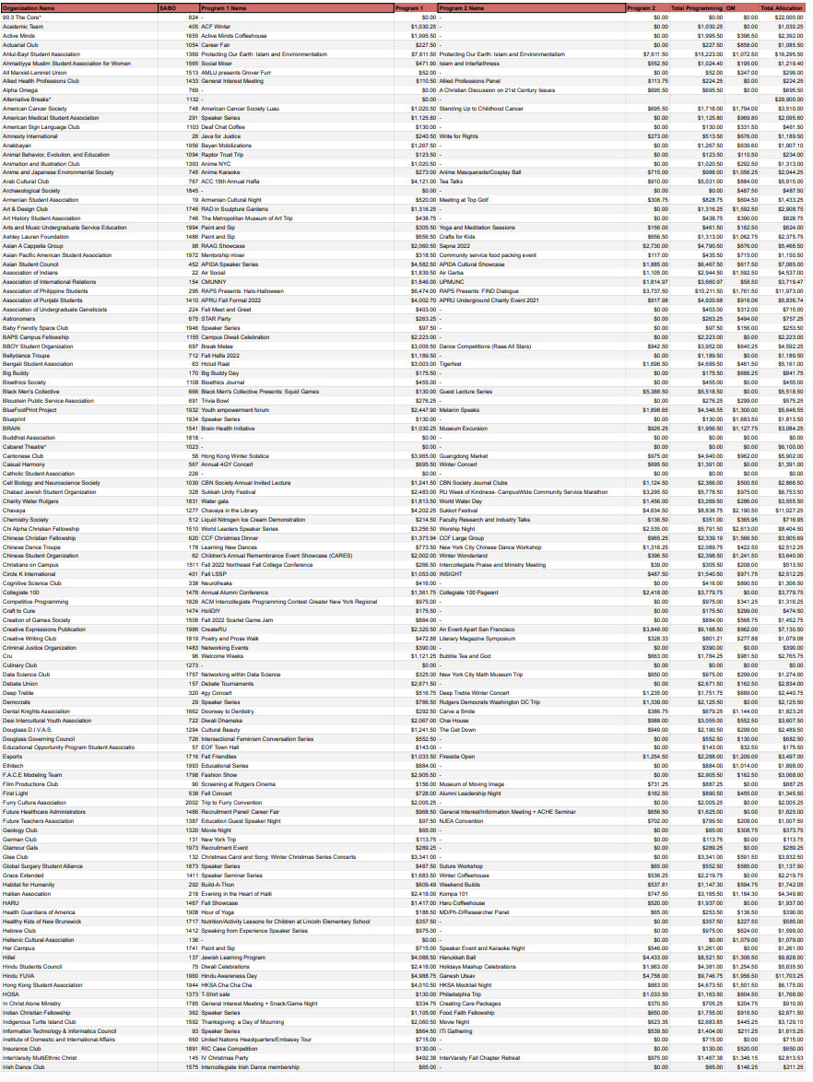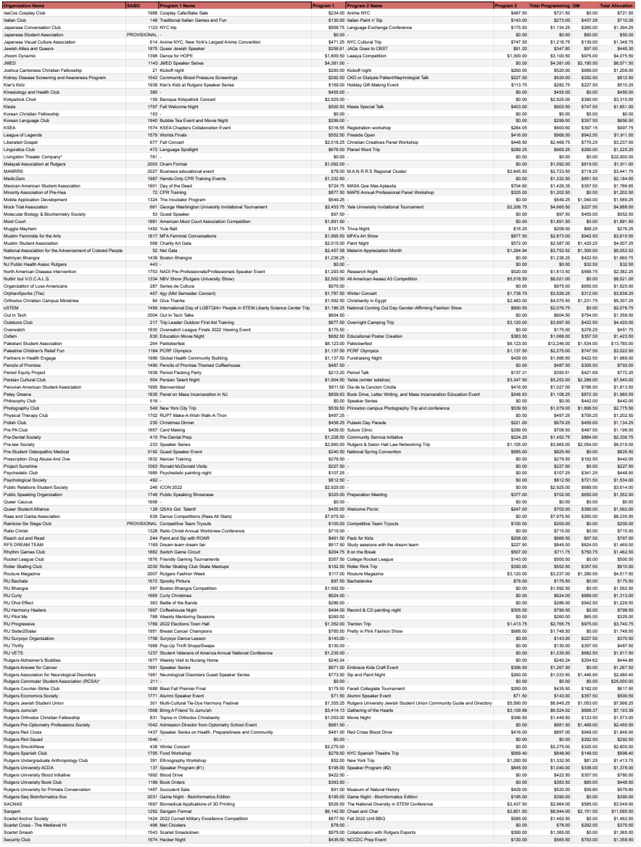

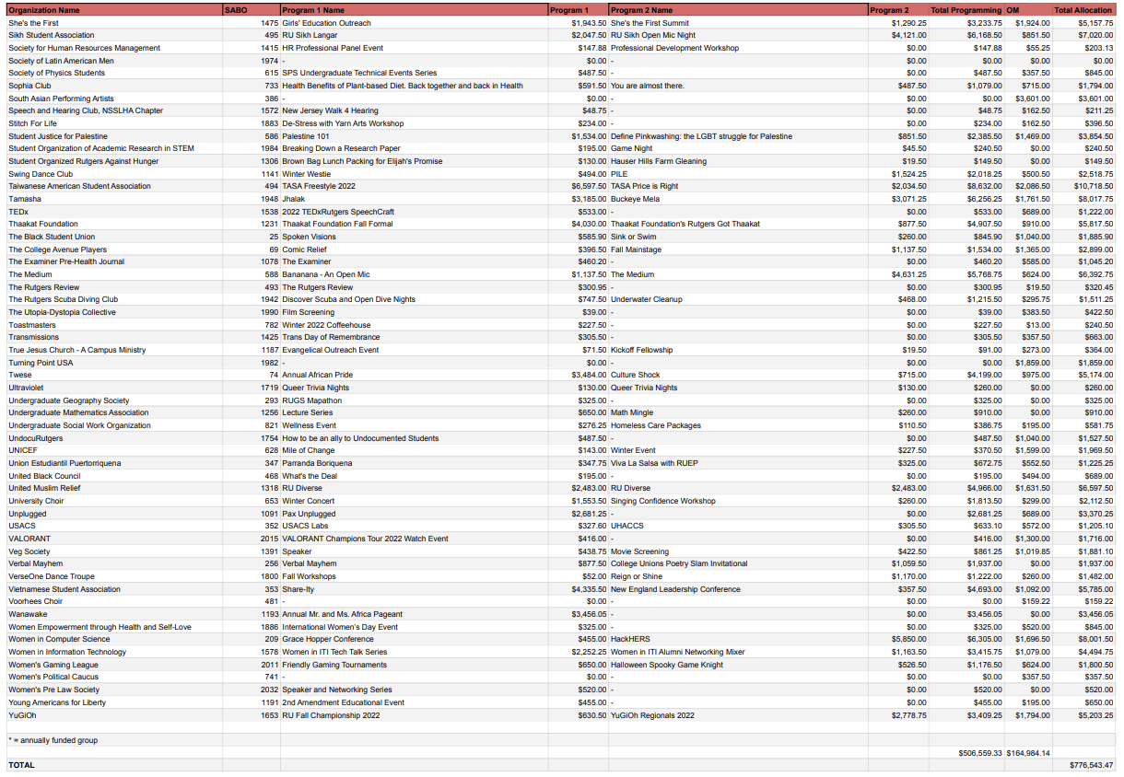

**Dates.**

## 

## Allocations Board Sponsorship

Introduced to the Allocations Board 18 April 2022

Passed by the Allocations Board 18 April 2022

Voted: Unanimous consent

## 

## Review by Executive Committee

Introduced to the Executive Committee xx April 2022

Approved for floor by the Executive Board xx April 2022

## Floor of the Assembly

Introduced to the Assembly 21 April 2022

Passed by the Assembly xx April 2022

Voted: ## yays, ## nays, ## abstains, ## presents